**Assignment 5. Thermal Remote Sensing**

**Question 1.**

1. Plot the spectral radiation from TU Delft.

The Planck function is evaluated as below.

$$L_{λ}=\frac{2hc^{2}}{λ^{5}(e^{x}-1)}$$

Where $x=\frac{hc}{kλT}$

h, Plank’s constant

k, Boltzmann’s constant.

$L_{λ}$, Spectral radiance.

C, the speed of light

T, temperature 291K

Consider it as a long wave, and then only the wavelength within the range of 4 to 100 $μm$ is taken into account.

In calculating spectral radiation, Python is used to facilitate such process (subroutines are attached in the appendix).

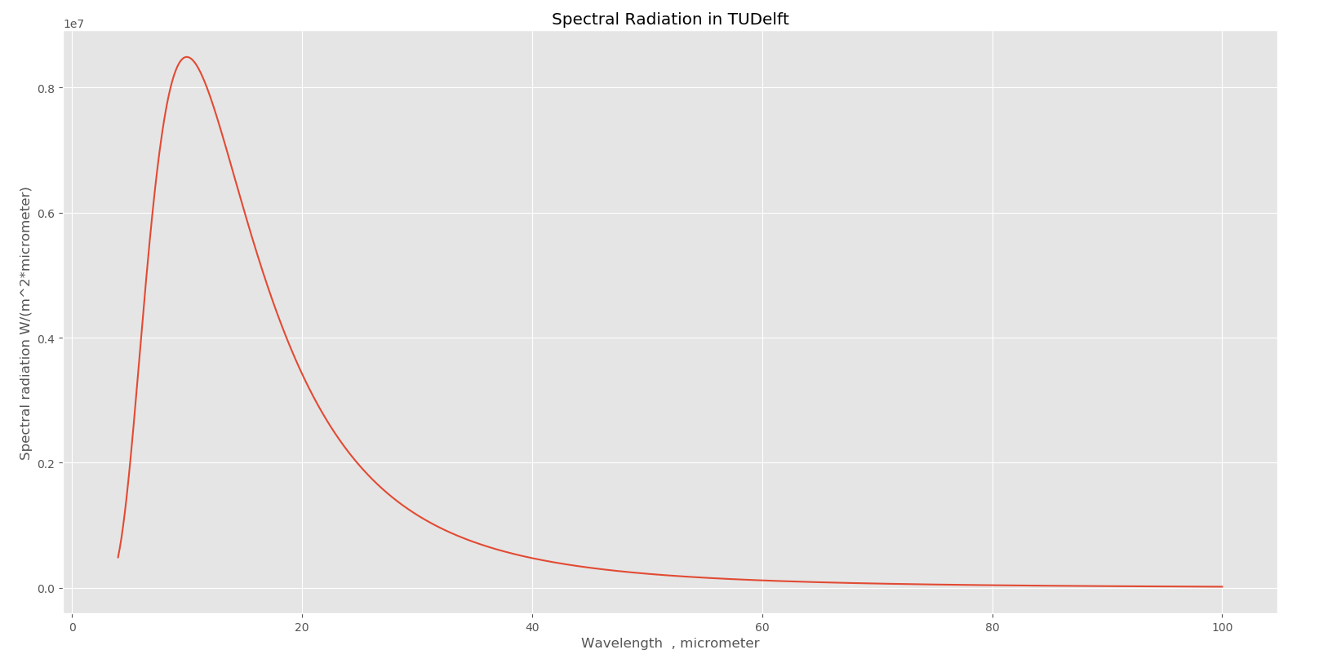

Fig.1 Spectral radiation in TUDelft

1. What is the total radiation from the city of Delft with a spectral interval of 11-15 $μm$?

$$R=πε\int_{4}^{λ}{L_{λ}dλ}$$

Where $ε,$ emissivity 0.95.

More specifically, narrow down the region of the wavelength to 11 to 15 $μm$

As there is no analytical solution of this integral, numerical approach is used instead in Python and codes are attached in the appendix.

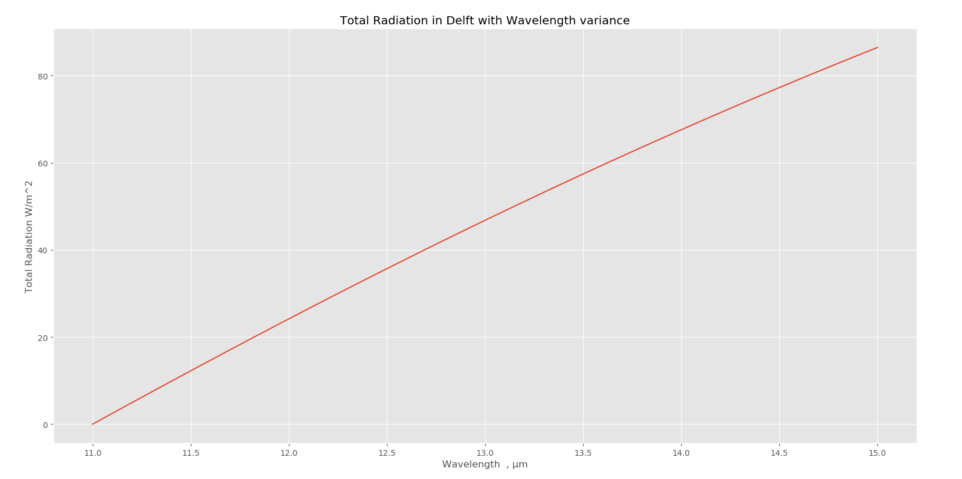

Fig.2 Total radiation in Delft

From this graph, we can read that at a wavelength of 15 $μm$, which means intergral from 11 to 15, the total radation energy is 86.44 $W/m^{2}$.

**Question 2. Identify areas with large vegetation in Burkina Faso and quantitively describe these areas.**

* Install “OpenLayers” plugin and open Google earth satellite.
* Import raster data “burkina_ndvi” into Grass and set its color map as NDVI color table.

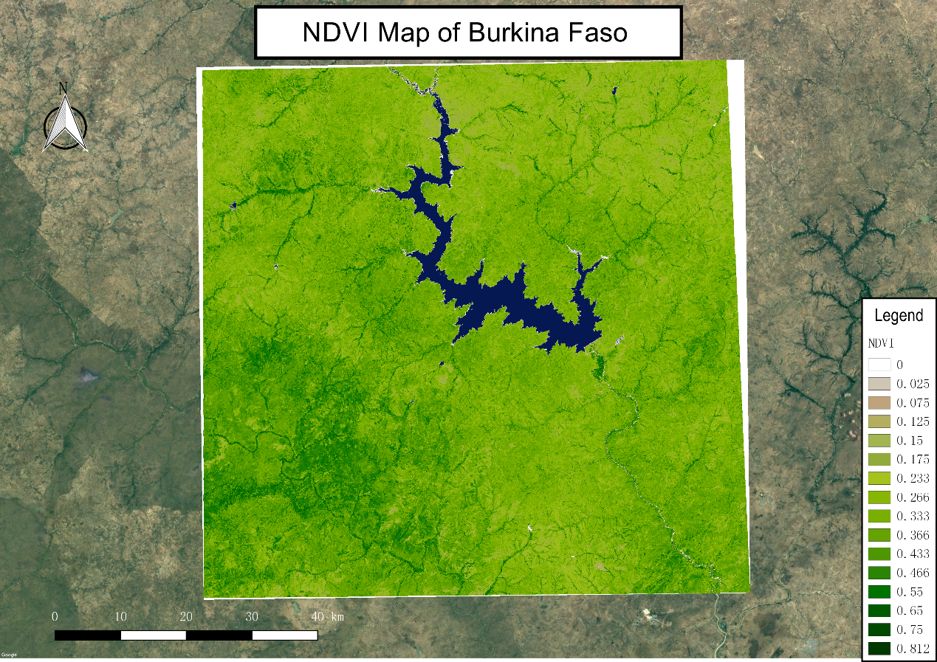

Fig.3 NDVI map in Burkina Faso

The map above illustrates the density of vegetation inside the Burkina Faso region. As expected, the black-green represents higher dense vegetation whose index can be up to 0.812 and the blue part states water body or small reservoirs.

**Question 3.**

* Import “burkina_surface_temperature” raster data into Grass.
* Set its color map as “Blue to red for temperatures in Kelvin scale”
* Open histogram of the current layer.
* Execute “r.univar” module, then the statistics of this raster data will pop up.

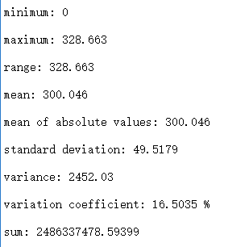

* Open histogram in the current layer.

|  |  |
| --- | --- |
|  |  |
| 1. histogram | 1. temperature distribution |

1. **What’s the lowest temperature values that occur?**

Even though the statistics show that the minimum value in the domain is 0 Kelvin, we could check that by opening the histogram of this layer inside properties and found that nearly zero values appear since around 294 K and ends up with around 320 K. We shall treat the minimum value of 0 as noise inside this region as we know the temperature could not be 0 K anywhere.

1. **What are the highest surface temperature values?**

As state above, the maximum value behaves correctly as 328 Kelvin.

1. **Explain the reasons for this significant difference in mid-morning temperature?**

In the temperature distribution graph, apparently, lower temperature occurs inside the water body and south-east part of the region which are highlighted because water is less sensitive to heat radiation. And for the southern part, comparing to NDVI map, found that these areas are filled with dense vegetation as for forests so that these vegetations protect these areas from being radiated by heat.

1. **Estimate the air temperature during this satellite overpass. Assume that the air temperature is spatially uniform, and provide some justification for the estimate and how to obtain it.**

Remote sensing from the satellite cannot measure the air temperature directly while the land surface temperature instead, and the other issue is that, because of satellite overpass, only day-time data is collected whereas losing sight of night-time observations.

To solve for these two issues, besides satellite data we collected, we are supposed to collect atmospheric temperature from meteorological stations to build a model of the relationship between satellite-derived data and in the situ measurements of surface temperature.

Of this, generally, we could obtain two regression model of day-time and night-time air temperature versus LST. In the assumption of spatially uniform air temperature, we could estimate air temperature everywhere in the domain.

**Question 4.**

* Import “burkina_albedo_toa” data into GRASS panel.

1. **Make a map of broad band surface albedo at surface level.**

For the short wave, the surface albedo is evaluated with the formula below.

$$ρ_{s,b}=\frac{ρ_{t,b}-ρ_{a,b}}{τ_{in,b}-τ_{out,b}}$$

Where $ρ_{t,b}$ broad-band top of atmosphere reflectance.

${ ρ}_{s,b}$ broad-band surface albedo.

$ρ_{a,b}$ top of atmosphere reflectance, 0.03.

$τ_{in,b}=τ_{out,b}$ single way atmospheric transmittance, 0.68.

* Calculate the surface albedo with raster calculator. “("burkina_albedo_toa@1"-0.03)/0.68/0.68”.
* Import generated map and make a composer.

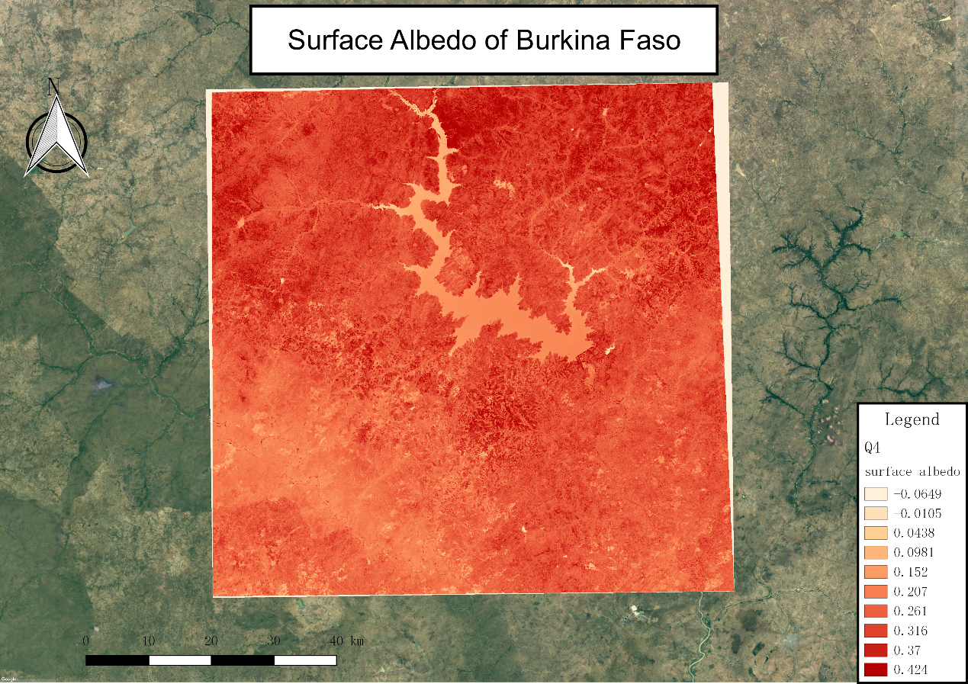

Fig.4 Surface albedo in Burkina Faso

1. **Make a histogram of broad-band surface albedo. What is the mean value for the entire image? Is this within the expected range of albedo values for this landscape?**

* Open properties, and click “histogram”.

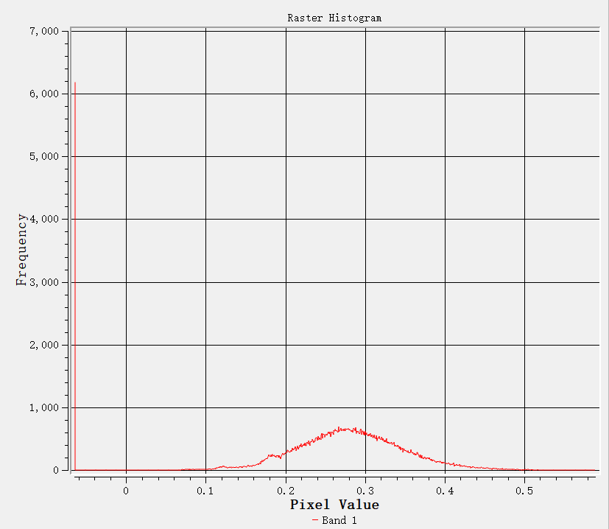

Fig,5 histogram of surface albedo distribution

* Inside properties, and click “Metadata”

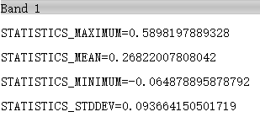

As shown, the mean value for the entire region is 0.268 which is within the range of expected albedo value.

**Question 5.**

1. **Make a map of net radiation of this area.**

The energy conservation equation is attached below.

$$R_{n}=\left(1-α\right)R_{s↓}+R_{L↓}-{ε_{s}R}_{L↑}-(1-ε_{a})R_{L↓}$$

Where $R_{n}$, net radiation, $W/m^{2}$

${ R}_{s↓}$ incident short wave radiation, $800 W/m^{2}$

${ R}_{L↓}$ incident long wave radiation, $W/m^{2}$, $ε_{a}σ{T_{a}}^{4}$

${ R}_{L↑}$ emitted long wave radiation, $W/m^{2}$, $ε_{s}σ{T_{s}}^{4}$

${ R}_{L↓}$ reflected long wave radiation, $W/m^{2}$

$α$ surface albedo (calculated above), 0.268

${ ε}_{s}$ surface broad-band emissivity, 0.95

$ε_{a}$ atmospheric emissivity, 0.85

$σ$ Stefan-Boltzmann constant, $5.67×{10}^{-8} W/m^{2}/K$.

${ T}_{a}$ Air temperature, we treat it as the mean value of land surface temperature, 300K.

$T_{s}$ Land surface temperature. K

* In raster calculator, type such syntax into the box.



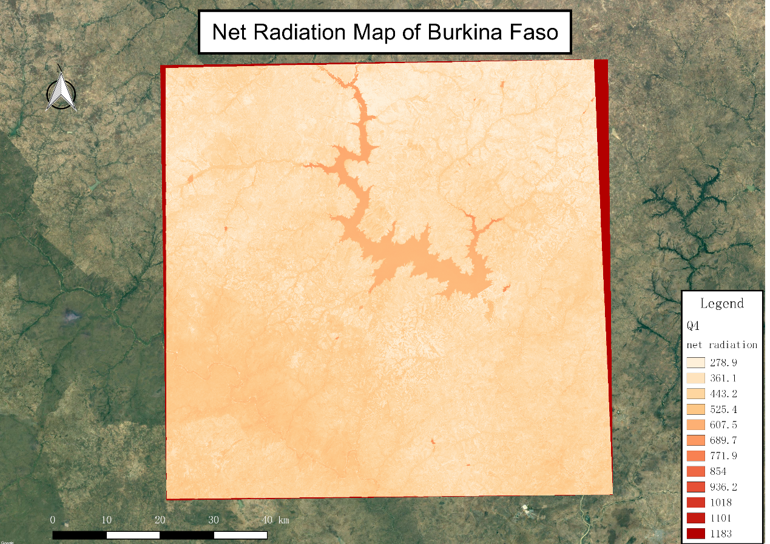

Fig. 5 Net radiation in Burkina Faso

1. **Prepare a histogram of net radiation during satellite overpass. Compute the spatial mean, the range of values. Explain the range of values and the variability.**

* Open “properties”, and click “histogram”

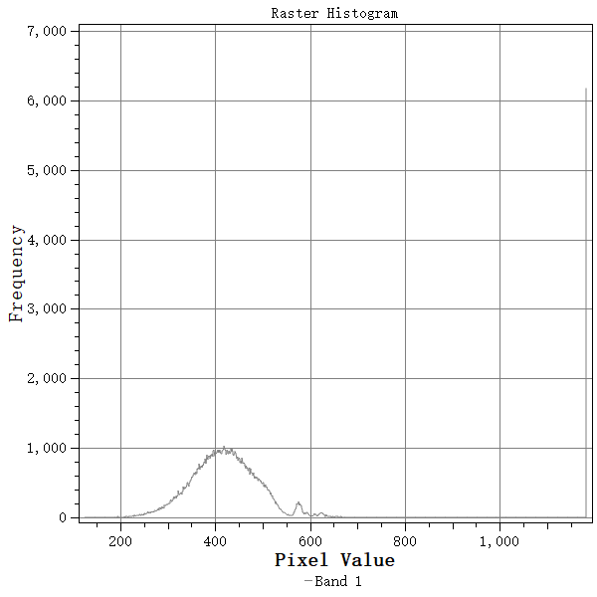

Fig.6 histogram of the radiation distribution

* Inside “properties”, and click “metadata”.

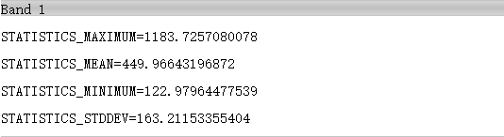

As shown, the range of the net radiation value is around 1000 $W/m^{2}$, and the spatial mean value is around 450 $W/m^{2}.$

According to the description, the net radiation is determined by energy conservation of input subtract output. As total input value is uniform inside this region, the output varies with the type of materials. As for water, the reflected radiation is limited because most of the energy is absorbed and reflects less. The same reason as for dense vegetation areas because it absorbs energy for the grow of vegetations and transforms to other materials such as oxygen in the photosynthesis process. But for bare soil, the albedo value is the most and temperature is relatively higher so that most energy is radiated out, and hence it has a relatively lower value of net radiation.

**Question 6. Compute and map the sensible heat flux in the study area.**

Sensible heat flux is computed with the equation:

$$H=-ρc_{p}\frac{dT_{a}}{r_{ah}}$$

Where H, sensible heat flux, $W/m^{2}$.

$ρ$ the air density, $1.15 kg/m^{3}$.

$c_{p}$ the specific heat capacity of air, $1004 J/kg/K$.

$r_{ah}$ the aerodynamic resistance (assume it is uniform everywhere), 130 $m/s$.

$T_{a}$ the air temperature (assume it is uniform), 300 $K$.

* In the raster calculator, type such syntax into the shell. “1.15*1004/130*("burkina_surface_temperature@1"-300)”
* Make a map of heat flux.

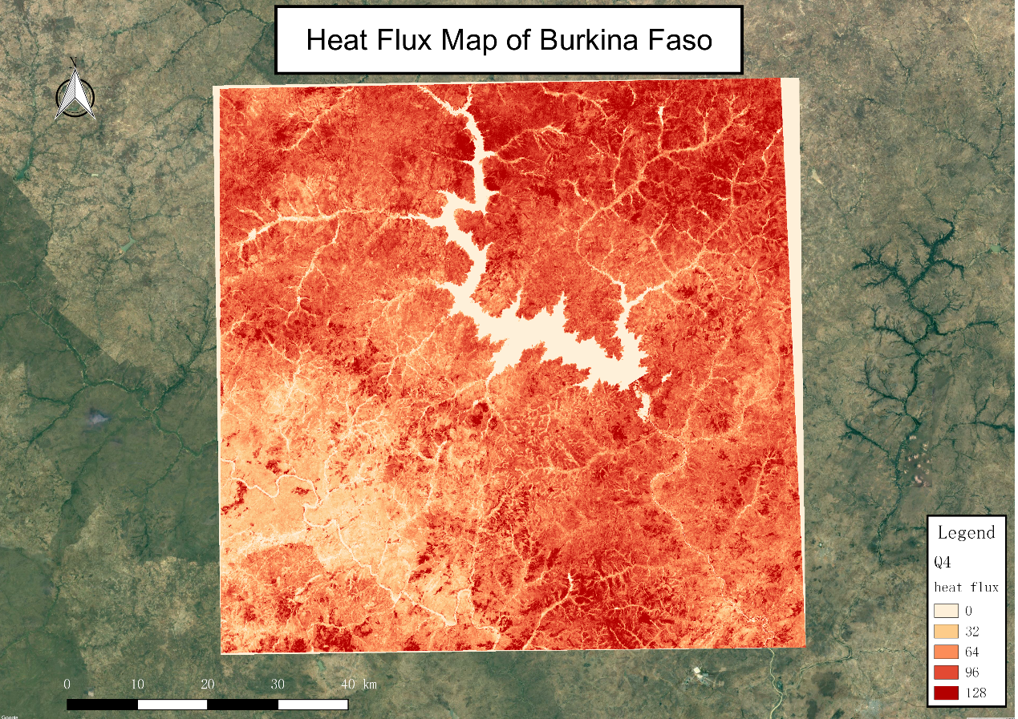

Fig.7 Heat flux in Burkina Faso

As expected, water body and dense vegetation have less heat flux and bare soil has more heat flux.

**Question 7. Compute and map the latent heat flux as the residual of the surface energy balance.**

The formula for latent heat flux is shown below.

$$LE=R_{n}-H-G$$

Where $R_{n}$ the net radiation, $W/m^{2}$.

$H$ the heat flux, $W/m^{2}$.

$G$ the ground heat flux, 0.1 $R_{n}$, $W/m^{2}$.

* In the raster calculator, type such syntax into the box. “"net radiation@1"-0.1*"net radiation@1"-"heat flux@1"”
* Make a composer.

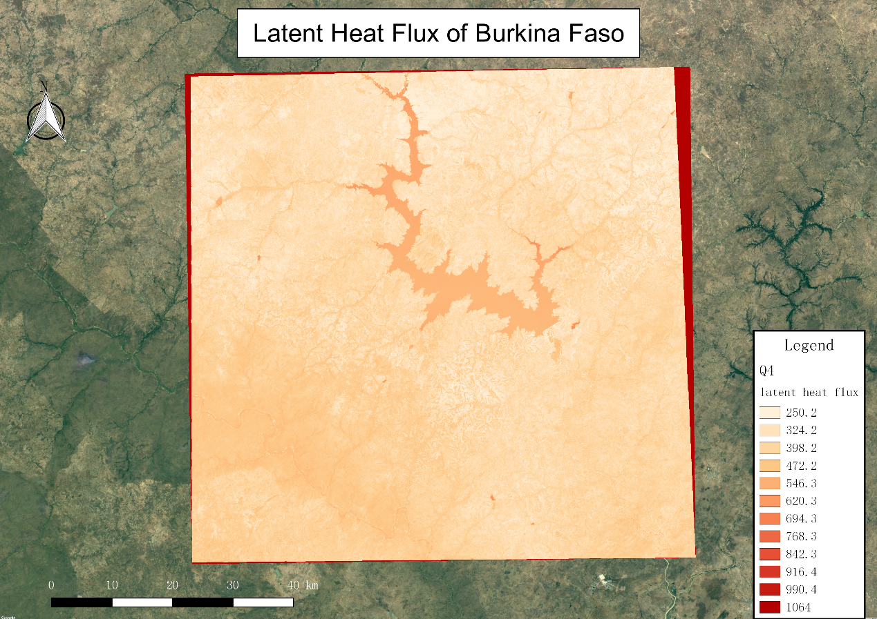

Fig.8 Latent heat flux in Burkina Faso

* Open “properties”, and click “metadata”

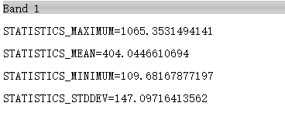

The mean value of latent heat flux is 404 $W/m^{2}$.

**Question 8. Estimate how much depth of water is evaporated in one hour, and prepare a spatial map of this actual rate of evaporation (mm/hour).**

The evaporation process can be transformed from latent heat flux, this approach is described below.

$$ET=\frac{LE}{ρλ_{V}}$$

Where LE, latent heat flux, $W/m^{2}$

$ρ$ water density, 1000 kg/m3

water evaporation rate, 2.5 MJ/kg

* Click on “raster calculator”, type such syntax into the box. “"latent heat flux@1"/1000/2500000*1000*3600” .
* Make a new composer.

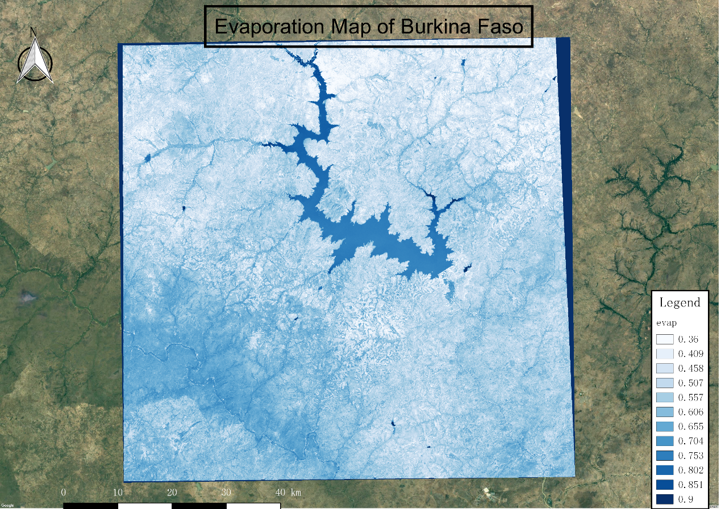

Fig.9 evaporation flux in Burkina Faso

From this map, areas in the water body and dense vegetations apparently evaporate or transpire much more water than those bare areas. Around the water body, we could identify some crops which are represented by light blue since irrigation in this area is more convenient. Evaporation in this area is beneficial because it maintains the local balance of the ecosystems and those evaporated water transforms to rainfall again. Besides, part of evaporation comes from transpiration, that is to say, vegetations photosynthesis is in progress, which means, they reproduce a large amount of oxygen for animals to survive. Nevertheless, water consumption is not sufficient to some extent as you can see some areas still have lower evaporation in general.

**Appendix: Python Codes**

*import numpy as np*

*import matplotlib.pyplot as plt*

*plt.style.use('ggplot')*

*from pylab import \**

*# Parameters.*

*x = np.linspace(4,100,2000)/10**(6)*

*# question a*

*ep = 0.95*

*def L(lab):*

*h = 6.63 * (10**(-34))*

*c = 3*(10**8)*

*k = 1.38 *(10 **(-23))*

*T = 291*

*sigma = 5.67 * (10**(-8))*

*x = h*c/k/lab/T*

*L = 2 * h *(c**2)/(lab**5)/(exp(x)-1)*

*return L*

*P = L(x)*

*plt.figure*

*plt.plot(x*10**6,P)*

*plt.xlabel('Wavelength , micrometer')*

*plt.ylabel('Spectral radiation W/(m^2/μm)')*

*plt.title('Spectral Radiation in TUDelft')*

*plt.show()*

*# question b*

*x = np.linspace(11,15,1000)/10**6*

*R = np.zeros(len(x))*

*import scipy.integrate as integrate*

*for i in range(len(x)):*

*R[i] = integrate.quad(L , 11*10**(-6) , x[i])[0]*ep*pi*

*plt.figure*

*plt.plot(x*10**6,R)*

*plt.xlabel('Wavelength , μm')*

*plt.ylabel('Total Radiation W/m^2')*

*plt.title('Total Radiation in Delft with Wavelength variance')*

*plt.show()*